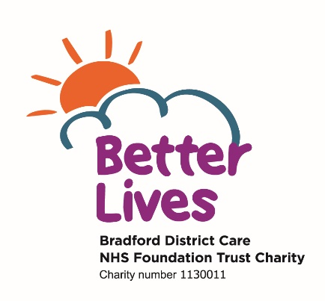

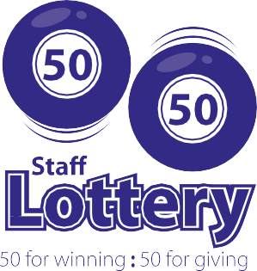
Please complete the application form below to join the prize draw
For more information contact Bradford Hospitals’ Charity on 01274 274809
Staff Lottery Application Form

The Staff 50/50 Lottery is open to all NHS employees at Bradford Teaching Hospitals NHS Foundation Trust and Bradford District Care NHS Foundation Trust.

The lottery is run by Bradford Hospitals’ Charity. 50% of the proceeds go towards prizes, and the remaining 50% is donated proportionately to Bradford Hospitals’ Charity and Better Lives Charity.

The donated funds support life-changing medical equipment and projects that go beyond NHS budgets, improving experiences for patients, families and staff.

- The lucky winners are drawn on the second Wednesday of each month.
- Each month, the prizes will be as follows:
1st - £500, 2nd - £250, 3rd - £100, 4th - £50.
- There are also extra cash prizes to be won as follows: Spring (April) - £2,500, Summer (July) - £2,500, Autumn (October) - £2,500 and Winter (January) - £2,500.

New Members | Please allocate me chance(s)
Existing Members | Please allocate me extra chance(s)

At £1.00 per chance per month, I authorise Payroll to deduct £ from my salary / wages

Title (Mr, Mrs, Miss, Dr) | First name: |  | Last Name:
Name of Trust: (please tick) BTHFT BDCFT
Department, location & postal addresses (work & home).  Work Home |  | Contact Number:
 |  | Contact Email (work and home)
 |  | Payroll Number:
 |  | National insurance number:
Signed:  By signing you agree to your name and Trust being published via the intranet, internal communications and social media. |  | Date:
Please note, we cannot accept incomplete forms or forms which have not been signed.

Please post to: Bradford Hospitals’ Charity, Trust Headquarters, Chestnut House, Smith Lane, Bradford BD9 6DA
Registered Charity: 1061753 Email: charity@bthft.nhs.uk Telephone: 01274 274809 Ref: Oct 23 Ref: Oct 2

